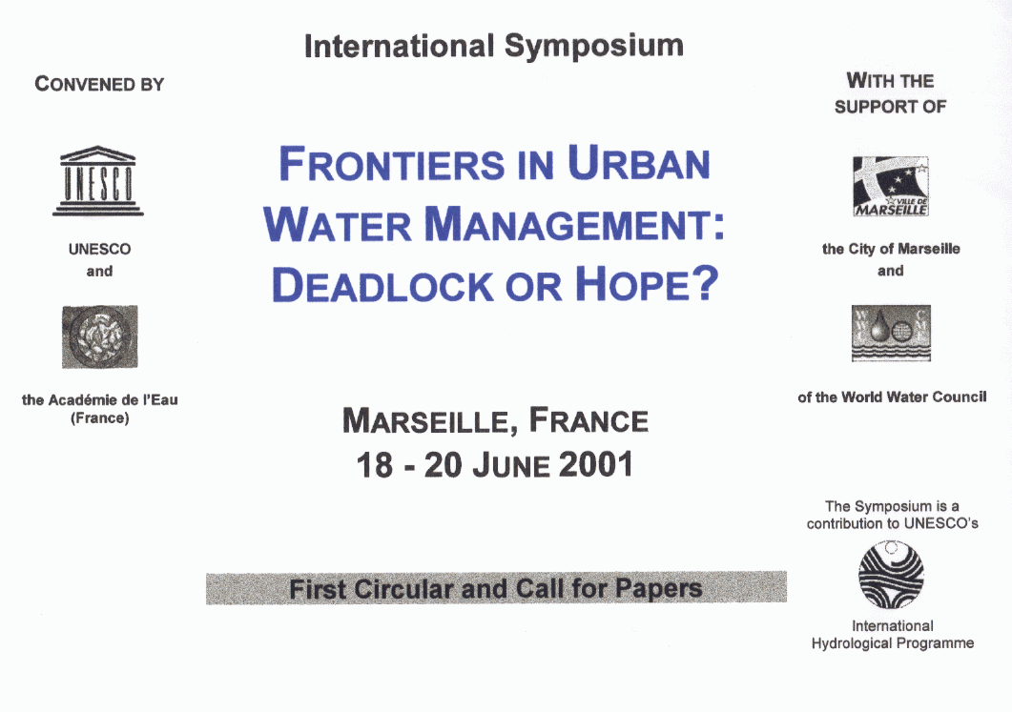

MAIN DIRECTIONS

The scope of the symposium falls within the broad objectives of the urban water component of UNESCO's International Hydrological Programme, and will focus on the water problems of cities and their conurbation.

The main theme includes hydrological, technical and managerial aspects, but will also cover the social and economic context.
The symposium is intended to stimulate thinking for decisions to be made on the ways water in the urban environment is to be managed, and on how cities should adapt in the future to withstand the pressures on their water dependent systems, including water supply and sanitation services, and not merely survive but add to the quality of life. The integrated urban water management concept will be highlighted as the approach to confront the problems.

The symposium will aim to assess present day's status and then will venture an outlook. An attempt will be made to assess whether the water and water-related health problems in cities and their surroundings are heading towards a dead-end or whether there are prospects for hope.

Ultimately, the symposium and particularly its workshops are expected to result in guidelines for sustainable development and for the solutions of current problems.

The symposium, while relevant to high level scientists and engineers, targets the decision-makers, urban water planners and managers and related practitioners; hence a symbiosis of research/science with practice is pursued. Interdisciplinarity and interactions will be emphasized, as well as the applicability to cities in industrialized and developing countries.

TOPICS OF PLENARY KEYNOTE LECTURES (AND OF THE PRE-SYMPOSIUM BOOK)

THE CHALLENGE OR URBAN WATER MANAGEMENT
A global view of developmental and environmental issues conditioning future urban water management and quality of life.

Urban water as a part of integrated catchment management
The effects of urbanization and urban water planning will be considered from the catchment perspective.

Interactions with the urban environment
The effect of withdrawals and inputs of water and of circulation (or recirculation) of water in the urban environment will be noted.

Infrastructure integration issues
The relationship and the integration of the different component of the urban water services will be examined within an urban planning context.

Emerging paradigms in water supply and sanitation
New approaches and alternative technologies that can alter traditional ways of solving age-old problems of water supply and sanitation are brought forward.

Urban water problems specific to developing countries
The water problems of cities in developing countries are reviewed critically: pattern of growth (including periurban areas), the nature of water services, technological and social factors, etc.

Economic and financial issues
The economic nature of water, financing of urban water projects in developing countries, sustainable financing of urban water management institutions and the role of international funding agencies are discussed.

Social, institutional and regulatory issues
The shift of the management paradigm, the relevance of the institutional framework and of the role of the stakeholders and the legal background will be examined.

Outlook for the 21st century
Based on the findings of the aspects treated above, perspectives for the 21 st century on urban water issues and promising approaches will be presented.

TOPICS FOR WORKSHOPS

1. Demand management practice, policy, data and technologies
- Conflicts in urban water demands
- Water conservation issues
- Supply side vs. demand side
- Reduction of losses
- Water quality issues
- Urban water management under scarcity conditions

2. Recycling and reuse at different scales
- Direct and indirect
- Urban irrigation
- Small scale: Local - building - development
- Wastewater as a resource
- Conflicts and possible solutions

3. Water and health
- Unsolved problems of urban hygiene in developed detries
- link between health knowledge and public decision
- Role of stakeholders in water and health policy
- Assessment of consequences of water on health

4. Technological outlook for the future
- Cutting edge technologies
- Reclamation of brackish/saline water
- Transfer of technology from developed to developing couversa
- Technologies for the cities of the future

5. Integrated urban water management
- Approaches for the future
- Institutional settings and capacity building issues
- Participatory processes
- Mitigation/prevention of urban flooding
- Emerging integrated solutions
- New planning and design tools (applied hydroinformatics

6. Private participation in the provision of urban water services
- Alternatives for private participation
- Recent innovations m developed and developing countries
- Private participation under different economic and politic
- The globalization of the provision of water services

VENUE, DATES AND ORGANIZATIONAL ASPECTS

The Symposium will be held at the Pharo Auditorium in Marseille (France) from 18 to 20 June 2001. 'fhe venue of the symposium is located at an outstanding historical site that overlooks the Old Port of Marseille.

The symposium will hold plenary sessions for the opening, and keynote lectures in the first day and the general discussion and closure in the afternoon of the third day. The middle part of the symposium will be devoted to six workshops.

The plenary sessions will be conducted in English and French with simultaneous interpretation. The workshops will be conducted in the two languages without interpretation, depending on the preference of the speakers. The plenary keynote lectures will present the findings of an expressly prepared publication. An invited speaker will introduce the topic of each workshop and limited time will be allowed for individual contributions. Pre-prints of individual contributed papers will be available at the symposium. There may be a limited number of travel grants for participants from developing countries with accepted papers. No registration fee will be charged. Published material will be on sale and social events will be charged.

CALL FOR PAPERS

The present circular constitutes an invitation to interested authors who wish to deliver a paper related to the Workshop topics above. They are kindly requested to submit an extended abstract in either English or French not to exceed three pages in length by 15 September 2000 to be addressed to:

J. A. Tejada-Guibert
Division of Water Sciences, UNESCO
1 rue Miollis
75732 Paris Cedex 15, France
Fax: +33 1 45 68 58 11
E-mail: Symposium2OOl@unesco.org

The Advisory Scientific Committee will decide on the acceptance of papers by 15 October 2000 and all authors will be informed of the decision by 31st October 2000. Instructions concerning accepted papers will follow. Full-length papers should be submitted by 15 January 2001.

The Second Circular will be issued in early 2001 and it will contain details concerning programme, acommodation and social events

SYMPOSIUM CHAIRPERSONS

J. A. Tejada-Guibert (UNESCO)
C. Maksimovic (U-IP)

INTERNATIONAL ORGANONG COMMITTEE (NOT FINAL)

M. Abu-Zeid (World Water Council)
J. Bartram (World Health Organization)
B. Braga (International Water Resources Association)
R. Coulomb (World Water Council)
C. George (International Association of Hydraulic Engineering and Research)
P. Hubert (International Hydrological Programme - France)
T. Milbum (International Water Association)
J. L. Oliver (Ministère de 1'équipement, des transports et du logement)
K. Ray (UNCHS - Habitat)
P.A. Roche (Agence de l'Eau Seine-Normandie)
D. Savic (International Association of Hydrological Sciences)
A. Szöllösi-Nagy (UNESCO)
P. F. Tenière-Buchot (United Nation Environment Programme)
F. Valiron (Académie de l'Eau)
J. C. Vial (Agence de l'Eau Seine-Normandie)

SCIENTIFIC ADVISORY COMMITTEE (NOT FINAL)

J. A. Abrishamchi (Iran)
M. P. Boudouresque (France)
D. Butler (UK)
L. Casanova (Japan)
B. Chocat (France)
M. Desbordes (France)
P. Harremoes (Denmark)
T. Lee (Chile)
J. Lundqvist (Sweden)
S. Matsui (Japan)
J. Marsalek (Canada)
J. Niemczynowicz (Sweden)
K. M. Nouh (UAE)
M. Saad (Egypt)
S. Saegrov (Norway)
J. P. Sotty (France)
D. Stephenson (South Africa)
C. Tucci (Brazil)
E. Vlachos (USA)

LOCAL ORGANIZING COMMITTEE (NOT FINAL)

City of Marseille
World Water Council Secretariat
Conseil Général des Bouches-du-Rhône
Conseil Régional Provence-Alpes-Côte d' Azur
Préfecture des Bouches-du-Rhône
Agence de l'Eau Rhône-Méditerranée-Corse
Groupe des Eaux de Marseille
Chambre de Commerce et d'Industrie Marseille Provence
