Focusing of a Parallel Beam to Form a Point in the Particle Deflection Plane
Ivar Ekland¹, Roger Temam², Jeffrey Dean², David Grove¹, Craig Chambers², Kim B. Bruce², and Elsa Bertino¹
¹Princeton University, Princeton NJ 08544, USA
²Université de Paris-Sud, Laboratoire d'Analyse Numérique, Bâtiment 425,
F-91405 Orsay Cedex, France
Abstract. The abstract should summarize the contents of the paper in at least 70 and at most 150 words, neither too long nor too short but to the point!
- Introduction
This is a sample paper for the WSC6 full paper submission guidelines. We advice you to download the Springer Author Template sv-crproc-e from the Springer website (on July 16, 2001, the url was http://www.springer.de/author/sv-crproc-e.zip) and follow the installation instructions. After that, when opening a new Word document, select the template svcrproc-e, and three rows of additional buttons appear on the title bar of your Word application. Use those buttons to typeset your document, either by typing the text, placing the cursor within the text and clicking on the selected button, or by selecting the format and start typing.
- How to use the template...
After installation, the three button rows help you to assign paragraph styles to your manuscript. One way is by opening a new document from template svcrproc-e and start typing the paper by selecting the button "Title", type the title, to press enter (style changes automatically to "Author") a.s.f. Otherwise, you may use this Word document and replacing the parts with your manuscript, or pasting your existing document in the newly opened document, placing the cursor into a text part and selecting the corresponding style. As for many other things: playing around a little bit with this template will help to make you comfortable.
- General settings
For title, authors, and address, type the text line by line, select either line and choose the corresponding button for the paragraph format. Authors from different locations are assigned differing numerical superscripts (see title of this document for an example).
The template gives you the standard paragraph format "p1a", with its button in the second row. The adjacent button is for indented paragraphs, which you may use for new paragraphs in a running text (as for this paragraph). Do not use indention after formulas or figures.
The font of the "p1a" style is based on your standard font. Set this to Times New Roman 11pt.
The top margin of the page should be 4cm.
- Other settings
Formulas. For formulas, use the formula editor of your Word program, as in:

$\begin{aligned}x=JH^{'}(t,x) \\ x(0)=x(T,t)\end{aligned}$ (1)

with $H(t,⋅)$ a convex function of x, going to $\text{+¥}$when $\left\|x\right\|→¥$.
Assign numbers to all formulas and equations, and place them enclosed in brackets on the right-hand side of the page. For referring to the equations within the main text you must simply write: see equation (1).
Subsections
The style offers you the section depth "H1", "H2" and "H3." Usually, depth two should suffice. It may be a little bit tricky to bring Word to a correct numbering of the subsections. The Springer template does not define the numbering by itself. For some versions of Word, we noted the following feature-bug: when you define the numbering, you have to set the pattern for the numbering format for level two or deeper according to the first occurrence of that sublevel in your text. So, if section 1 has no subsections, but there is one subsection in section 2, you have to set this pattern to 2.1. If in trouble, set the section numbers by hand.
You may have noted that equations are numbered automatically when you use the equations paragraph format. However, here you will find an example for the a sub-numbering of equation arrays that has to be done manually:

$a=c+d$ (2a)
$e=f−d$ (2b)

Word is not LaTeX, so do not expect too much from the templates!

No Sub-numbering. Putting all parts of the formula into one object can do this:

$\begin{aligned}a=c+d \\ e=f−d\end{aligned}$ (3)

Footnotes. Use them sparingly. They should look like. Edit the footnote later by double click on the footnote symbol in the text.

Keywords: The Springer template does not provide an extra format for a keyword list. However, we expect from you a maximum of five keywords to be submitted electronically on the WSC6 paper upload page.
- Figures
For figures, convert them into a format that can be recognized by Word, as e.g. the Tagged Image File Format (TIFF), file extension .tif. Make sure that the graphic is included and not just referenced in the Word document. Also, the document is supposed to be printed, so if you are using a vector graphic program, then export the graphic with high resolution (300dpi) before using it in a Word document.
For the layout of multiple graphics, tables are a good instrument. But do not use the Springer table template here, rather use the regular Word table template.
Figures and their captions (use the "Figure Legend" button for the caption) should be centered. The Springer templates do not center the images, so you have to adjust the images by yourself. Also, leave one line space between the text and the figure.

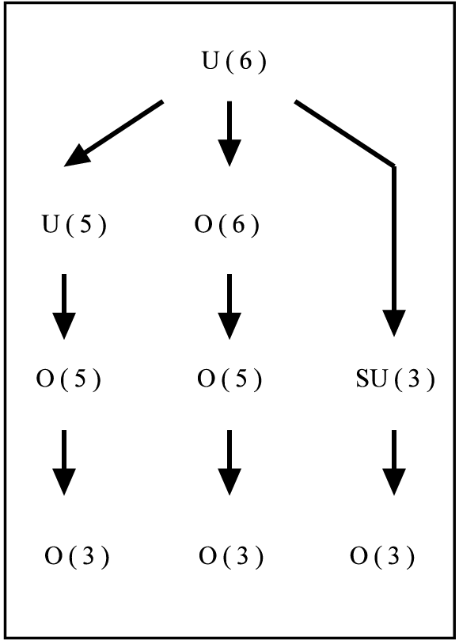
Fig. 1. Example of an electronically included tif-image.

Refer to figures in the text like Fig. 1, but write Figure 1 at the beginning of a sentence.
- Pseudo-Code
For typesetting pseudo-code in your paper, you will find the paragraph format programcode (this is the same as using the font Courier) in the format list:

for i=1 to 100 do
for j= 1 to 100 do
echo i*j;
end j;
end i;

Separate pseudo-code by one line from the text.
- Tables
The Springer Template offers a nice table template. Create a new table by using the table template in the lower button row, and then set up your table as usual. For the table caption, use the "Table Title" button, and put the caption above the table.
Refer to tables in the text via e.g. Table 1. In the following, you see an example for a table. Tables are left-flushed, and should not exceed the page width.
Table 1. Some styles.
Style | Font | Size | Attributes | Separation bef./aft. in point
p1a | TNR | 10 |  | -/-
title | Helvetica | 14 | bold | -/23
author | TNR | 10 |  | -/11
authorinfo | TNR | 10 |  | -/36
abstract | TNR | 10 |  | 6/0
heading1 | Helvetica | 12 | bold | 26/14
heading2 | Helvetica | 12 | bold | 22/11
heading3 | Helvetica | 10 | bold | 16/8
figlegend | TNR | 9 |  | 6/12
tablelegend | TNR | 9 |  | 12/6
reference | TNR | 9 |  | 11/0
(TNR = Times New Roman)
- Lists
The Springer Template defines its own list format so that you will receive bullets instead of dashes to introduce the individual items. However, the standard list

- is clear
- looks good
- is noticeable

as well (but you may decide this on your own...). You will find the lists buttons in the second row of the Springer template.

The paper ends with the Acknowledgment and Reference sections. Here, we have defined a "heading1*" format for suppressing the automatic numbering of those sections. Give references in the text by numbers [1], and list them in the reference alphabetically by using the "Reference" button. See below.
References
1. Holzwarth F., Lenz J. et al. (1998) 1readme. Further Details on Layout and LATeX code. Springer, Berlin Heidelberg
2. Turner, J.S. (1974) Double-diffusive phenomena. Ann. Rev. Fluid Mech. 6, 37-56

This text is a footnote.

