HD SANTA RITA VINEYARD WITH LUNCH

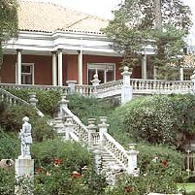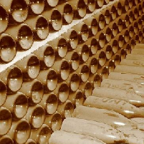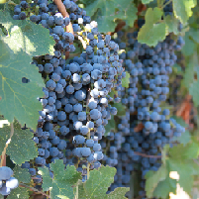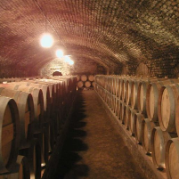

We go to the Maipo Valley, located in the heart of metropolitan region and is one of the most traditional wine country, on one side of the Rio Maipo. It was in this sector where the first vineyards were founded favored by excellent weather conditions and soil between the Andes and coastal mountains.
Taking advantage of the Mediterranean climate, with frost at specific times, take out the country's finest wines, especially Cabernet Sauvignon strain emerges with its intense color, delicate aromas and fruit tones.

Viña Santa Rita was founded in 1880 by Domingo Fernández Concha and its development is brought French technology. In the cellars of stores, meanwhile, used barrels of French and American oak where the wine acquires complexity and body, woody flavor and a soft and delicate aroma. In High Jahuel is one of the oldest wineries in Chile saved. There are aged in a cellar the best wines of the vineyard as the Casa Real and Medalla Real Cabernet Sauvignon. This winery, declared National Monument, was built by French architects and their material is tight.

Walk facilities in Viña Santa Rita High Jahuel, is a fascinating journey through the history of Chile and especially the history of Viña Santa Rita.

During the following years the reputation of their products was increasing and also the beautiful and natural environment infrastructure that was created around him.

Later, go to the restaurant Doña Paula, now a National Monument was named after Dona Paula Jaraquemada, who was the owner of the main house of Hacienda Santa Rita for over 200 years. At that time, this place was the scene of significant historical events associated with the independence of Chile. Here we enjoy a tasting and then lunch. Finally he takes the trip to Santiago to your hotel.

Technical Details

Availability: Tuesday-Sunday (Subject to availability).
Departure Time: 11:00 hrs or 13:00 hrs.
Duration: 4 Hrs
Capacity: No limit.
1 | 2 | 3 | 4 | 5

Difficulty: Easy Most Strenuous
Local People Contact:

Highlights: Santa Rita Vineyard, Wine tasting and demonstration of wine production processes.
Meals included: Lunch (menu)
Special Requirements: None.
Type of accommodation: N/A
Shopping opportunities: Yes
Access to toilets: Yes
We suggest bringing: Comfortable clothing, sun protection and camera.

Excursion includes

- Transport.
- Bilingual Specialist Guide.
- Tour and Wine tasting en Santa Rita Vineyard.
- Lunch (menu).

Excursion does not include

- Anything not mentioned in the above description and details.

Cancellation Policy

- General Terms and Conditions apply.

MAPA DE RUTA

