FD VIÑA DEL MAR Y VALPARAISO PATRIMONIAL

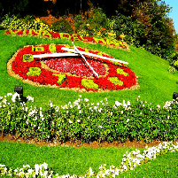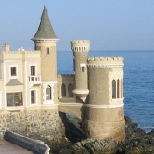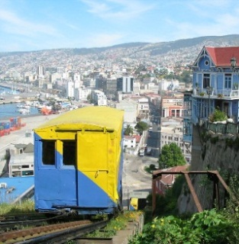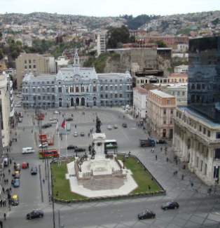

It began with a visit Viña del Mar, where the flower clock, located opposite the beach of Caleta Abarca, they will welcome the Garden City. Castillo Wulff, emblematic building of the city, neo-Tudor style, built in 1906. Strategically situated on some rocks on the coastline. In 1995 he was declared a national monument, but now houses the offices of the headquarters of the Heritage Unit of the Municipality of Viña del Mar. We continue to meet Vergara Palace built in 1906 by the daughter of the founder of Vina del Mar, is considered Historic Building and / or Architectural.
There is also the Valparaiso Sporting Club, one of the foremost equestrian clubs of Chile and former roots, dating back to times close to the city early in the nineteenth century. We continue our tour of the coastal road toward Reñaca and we stop at the "Rock of the Wolves" here you can observe the wildlife, fauna and beautiful natural surroundings, as well as the bay to Valparaiso, then continue towards the city of Valparaíso.
Valparaiso world heritage and cultural capital of Chile, we can deliver to you a new tour where we will go into daily life in the artists' galleries and heritage architecture that will enable us to better understand the history of the great Valparaiso.
Tour starts in the streets in Brazil with the imposing monument donated to Valparaiso English, then we went into the street with houses Britain dating from the early twentieth century, noting these wonderful buildings reach the lookout May 21 with a stunning view Bay, after enjoying the view and watch the city from above, coming down the elevator and then move to Artillery Victory Square and take the elevator to visit the Holy Spirit Open Air Museum to continue to La Sebastiana (not available on Mondays).
Then we went to the Plaza de San Luis to start a walking tour through the Cerro Concepción, visiting the streets nineteenth century buildings such as Saint Paul's Church, Lutheran Church and the famous promenade Atkinson, with his famous restored Brighton.
Then we moved to Cerro Alegre via the Paseo Gervasoni, wherein the famous Café Turri and the house dedicated to the memory of journalist and cartoonist Lukas (Renzo Pechenino), then continue along certain streets with their unique architecture arrive at Cerro Alegre, to know the Yugoslav and Palace Walk Baburizza with its breathtaking view of the bay, then descend by elevator to reach the Pearl Plaza Sotomayor, civic center in the first third of the nineteenth century, here we can see the monument to the Heroes of Iquique where the remains of Prat, Serrano, Condell and others.
Also visit the Prat Pier and traditional boats that take you around the bay and then pass by the Plaza Aníbal Pinto where there are shops prestigious painters, sculptors and artisans in the area, see the famous Cinzano Bar and others.

Technical Details

Availability: Every day (except on monday).
Departure Time: 09:00 a.m.
Duration: 8 Hours.
Capacity: No limit.
1 | 2 | 3 | 4 | 5

Difficulty: Easy Most Strenuous
Local People Contact:

Highlights: Viña del Mar, Valparaíso and La Sebastiana Museum.
Meals included: Lunch (menu).
Special Requirements: Be able to walk pathways.
Not suitable for disabled passengers.
Type of accommodation: N/A.
Shopping opportunities: Yes.
Access to toilets: Yes.
We suggest bringing: Comfortable clothing, sun protection and camera.

Excursion includes

- Transport
- Bilingual Specialist Guide
- Funiculars / “ascensores”
- Ticket for La Sebastiana museum.
- Lunch (menu).

Excursion does not include

- Anything not mentioned in the above description and details.

Cancellation Policy

- General Terms and Conditions apply.

